Seed Block Algorithm: A Remote Smart Data Back-up Technique for Cloud Computing

ABSTRACT
In cloud computing, data generated in electronic form are large in amount. To maintain this data efficiently, there is a necessity of data recovery services. To cater this, in this paper we propose a smart remote data backup algorithm, Seed Block Algorithm. The objective of proposed algorithm is twofold; first it help the users to collect information from any remote location in the absence of network connectivity and second to recover the files in case of the file deletion or if the cloud gets destroyed due to any reason. The time related issues are also being solved by proposed SBA such that it will take minimum time for the recovery process. Proposed SBA also focuses on the security concept for the back-up files stored at remote server, without using any of the existing encryption techniques.
EXISTING SYSTEM:

The recent back-up and recovery techniques that have been developed in cloud computing domain such as HSDRT, PCS, ERGOT, Linux Box, Cold/Hot backup strategy etc. Detail review shows that none of these techniques are able to provide best performances under all uncontrolled circumstances such as cost, security, low implementation complexity, redundancy and recovery in short span of time.

DISADVANTAGES OF EXISTING SYSTEM:
- High cost
- Time complexity

PROPOSED SYSTEM:

The objective of proposed algorithm is twofold; first it help the users to collect information from any remote location in the absence of network connectivity and second to recover the files in case of the file deletion or if the cloud gets destroyed due to any reason.
ADVANTAGES OF PROPOSED SYSTEM:
- Recover same size data
- Low host
- Privacy

Modules:
1. Cloud Computing

Cloud computing is the provision of dynamically scalable and often virtualized resources as a services over the internet Users need not have knowledge of, expertise in, or control over the technology infrastructure in the "cloud" that supports them. Cloud computing represents a major change in how we store information and run applications. Instead of hosting apps and data on an individual desktop computer, everything is hosted in the "cloud"—an assemblage of computers and servers accessed via the Internet.
Cloud computing exhibits the following key characteristics:
1. Agility improves with users' ability to re-provision technological infrastructure resources.
2. Cost is claimed to be reduced and in a public cloud delivery model capital expenditure is converted to operational expenditure. This is purported to lower barriers to entry, as infrastructure is typically provided by a third-party and does not need to be purchased for one-time or infrequent intensive computing tasks. Pricing on a utility computing basis is fine-grained with usage-based options and fewer IT skills are required for implementation. The e-FISCAL project's state of the art repository contains several articles looking into cost aspects in more detail, most of them concluding that costs savings depend on the type of activities supported and the type of infrastructure available in-house.
3. Virtualization technology allows servers and storage devices to be shared and utilization be increased. Applications can be easily migrated from one physical server to another.
4. Multi tenancy enables sharing of resources and costs across a large pool of users thus allowing for:
5. Centralization of infrastructure in locations with lower costs (such as real estate, electricity, etc.)
- Utilization and efficiency improvements for systems that are often only 10–20% utilized.
- Reliability is improved if multiple redundant sites are used, which makes well-designed cloud computing suitable for business continuity and disaster recovery.
8. Performance is monitored and consistent and loosely coupled architectures are constructed using web services as the system interface.
9. Security could improve due to centralization of data, increased security-focused resources, etc., but concerns can persist about loss of control over certain sensitive data, and the lack of security for stored kernels. Security is often as good as or better than other traditional systems, in part because providers are able to devote resources to solving security issues that many customers cannot afford. However, the complexity of security is greatly increased when data is distributed over a wider area or greater number of devices and in multi-tenant systems that are being shared by unrelated users. In addition, user access to security audit logs may be difficult or impossible. Private cloud installations are in part motivated by users' desire to retain control over the infrastructure and avoid losing control of information security.
10. Maintenance of cloud computing applications is easier, because they do not need to be installed on each user's computer and can be accessed from different places.

2. Data security
Giving full protection to the client’s data is also the utmost priority for the remote server. And either intentionally or unintentionally, it should be not able to access by third party or any other users/client’s.
3. Remote Data Backup server
The main cloud is termed as the central repository and remote backup cloud is termed as remote repository. And if the central repository lost its data under any circumstances either of any natural calamity (for ex - earthquake, flood, fire etc.) or by human attack or deletion that has been done mistakenly and then it uses the information from the remote repository. The main objective of the remote backup facility is to help user to collect information from any remote location even if network connectivity is not available or if data not found on main cloud.

- SYSTEM ARCHITECTURE:

- 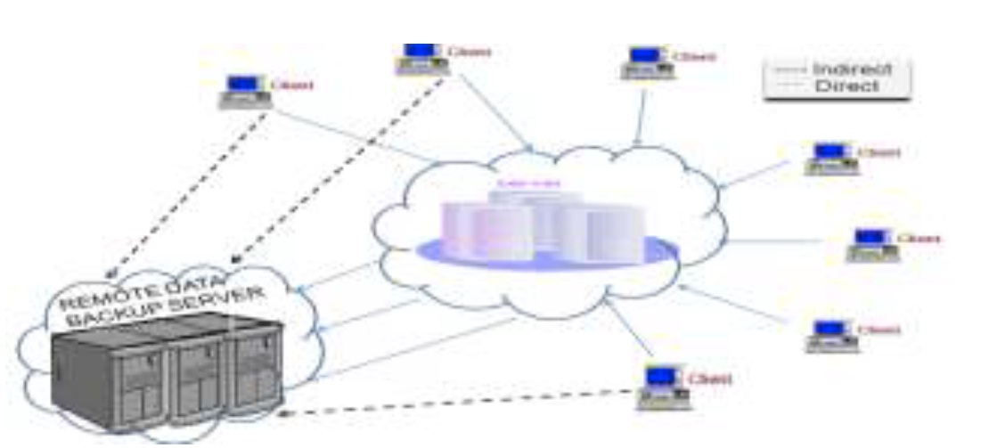
Algorithm Techniques:

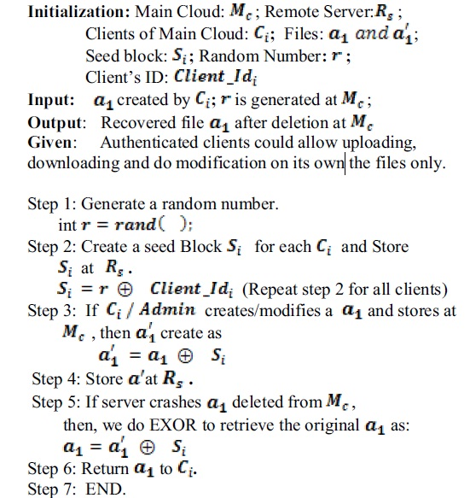
System Configuration:-

H/W System Configuration:-

Processor - Pentium –III

Speed - 1.1 Ghz
RAM - 256 MB(min)
Hard Disk - 20 GB
Floppy Drive - 1.44 MB
Key Board - Standard Windows Keyboard
Mouse - Two or Three Button Mouse
Monitor - SVGA

S/W System Configuration:-

Operating System :Windows95/98/2000/XP
Application Server : Tomcat5.0/6.X
Front End : HTML, Java, Jsp
Scripts : JavaScript.
Server side Script : Java Server Pages.
Database : Mysql
Database Connectivity : JDBC.

CONCLUSION

We propose a novel resource allocation algorithm for cloud system that supports VM-multiplexing technology, aiming to minimize user’s payment on his/her task and also endeavor to guarantee its execution deadline meanwhile. We can prove that the output of our algorithm is optimal based on the KKT condition, which means any other solutions would definitely cause larger payment cost. In addition, we analyze the approximation ratio for the expanded execution time generated by our algorithm to the user-expected deadline, under the possibly inaccurate task property prediction. When the resources provisioned are relatively sufficient, we can guarantee task’s execution time always within its deadline even under the wrong prediction about task’s workload characteristic.

